Copperhead Firmware Instructions

# Printrboard

Newer Printrboards come with a CDC (USB Communication Device Class) bootloader installed. This allows the Printrboard to use drivers that should be pre-installed on your Windows system. These instructions assume a CDC bootloader. (TODO: Document installing the CDC bootloader on incompatible Printrboards.)

1. Place the boot jumper on the boot pins of the Printrboard. IMPORTANT: Do not remove the boot jumper until told to do so!
2. Reset the Printrboard using the reset button so it enters the CDC bootloader. As you reset the device you’ll see the COM port number change in Windows Device Manager
3. If you haven’t already, unzip **XLoader.zip** located in **Tools/XLoader** to your desktop.
4. Double click **XLoader.exe**.
5. Select the **Hex file** you want to upload to your Printrboard.
6. Select **Printrboard** from the **Device** drop down menu.
7. Select the new **COM port** for the Printrboard in CDC bootloader mode.
8. Set the **Baud rate** to **250000**.
9. Your settings should look something like this:  
   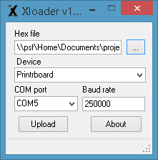
10. Click the **Upload** button to upload the firmware to the Printrboard. As the file uploads you’ll see an **Uploading…** status message at the bottom of the window. When the upload is complete, the number of bytes uploaded will be displayed.
11. Remove the boot jumper from the boot pins on the Printerboard.
12. Reset the Printerboard using the reset button to boot the new firmware.
13. You can now attempt to connect to the Printrboard using your favorite printer management software.